**KODA CAMP**

**101**

**A guide for anyone interested in starting a KODA camp/workshop.**



**Amy Claridge**

**CODA UK & Ireland Under 18s Director**

This guide has been set up in order to help newly formed CODA/KODA groups gain an idea of what is happening elsewhere to hopefully encourage the global development of K/CODA and further support K/CODAs worldwide. This is by no means a complete and comprehensive guide and if you have any further questions please contact me at [amy@codaukireland.co.uk](mailto:amy@codaukireland.co.uk). Generally speaking, I am dividing this guide into the following areas:

**Table of Contents**

**INTRODUCTION: MY EXPERIENCE OF CAMP** **3**

**CAMP FORMAT** **6**

**CAMP SCHEDULE** **11**

**FREE TIME & FILLER GAMES** **13**

**ARTS & CRAFTS ACTIVITIES** **14**

**TEAM BUILDING GAMES/ICEBREAKERS** **15**

**DEAF STUDIES/KODA GAMES** **16**

**PHYSICAL EDUCATION GAMES** **19**

**DEAF INVOLVEMENT** **20**

**KODATHALON** **21**

**CHANTS** **21**

**BEHAVIOUR MANAGEMENT** **24**

**WORKSHOPS** **26**

**CONCLUSION** **28**

Please note the term CODA refers to Children of Deaf Adults (generally those over 18) whereas KODA refers to kids of Deaf adults (generally under 18s).

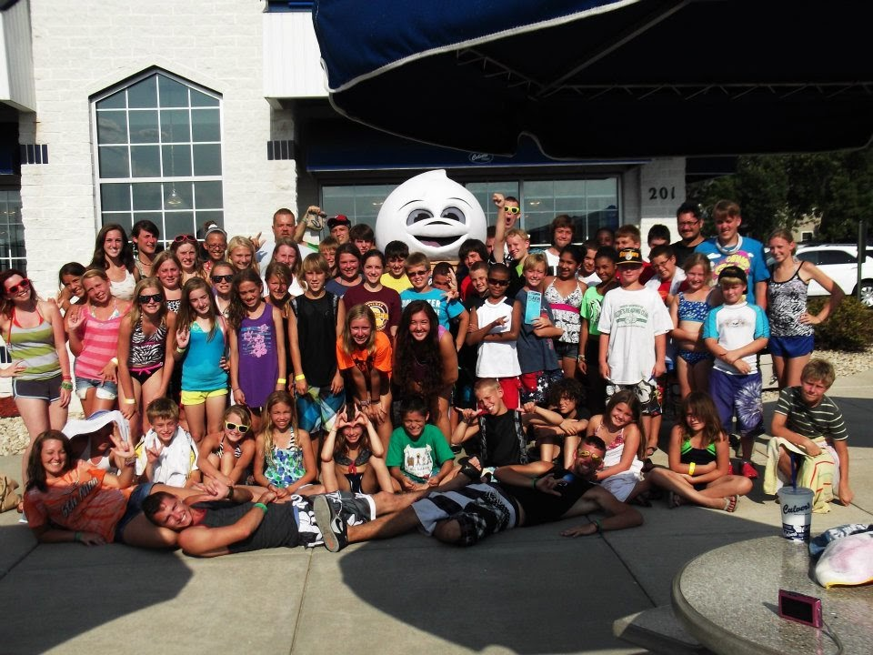

# INTRODUCTION: MY EXPERIENCE OF CAMP

I remember being an outsider to the CODA world and first looking into camp and thinking 'yeah that looks like fun' but not really considering that there would be any major impact on the children and never anticipated how much it would affect myself and my life. My first proper experience of CODA was aged 19 flying half way around the world from my small town of Wales in the UK to KODA Camp Mid-West in the USA. Before this point, I’d only met one CODA in my life who mentioned what CODA was and that it was not really a thing in the UK but was a “big deal in the USA, they have camp there for it and everything”. With that, one email and interview later, I flew halfway around the world and by the time I’d left I’d been there for 5 weeks and felt like my world had been turned upside down. I felt like 120 strangers knew and understood me better than half of the people I’d grown up with. I laughed, I chanted, I bonded and I cried for three days straight when it finished. The first thing I did when I arrived back to the UK was emailed the CODA UK & Ireland Board and insist, we needed one of these camps here in the UK. I joined the board and 6 years later we are now on our 6th camp over here! I even gave up my own University graduation to come to camp as I knew as soon as I embarked on a career in teaching, I wouldn’t be able to go to the USA camps again (darned short British summer holidays!). Despite this, I got a fake camp graduation and 8 camps later and I am now one of the Directors at the UK camp, a Director at CODA UK & Ireland and have been involved with CODA Kenya, trying to set up workshops over there. I promised I would write a guide so here it is!

KODA Camp has many major impacts, one of the biggest I feel simply comes from being around other CODAs. The CODA upbringing is unique and can be significantly different to the experience of most CODAs’ hearing peers. As many KODAs mature early especially if they take on the role of language brokering at a young age, the entire existence of camp and general fun games allows 'kids to be kids' for once. During their time at camp children will share experiences and realise through interactions with other KODAs that 'ME YOU SAME'. As a CODA who only met her first CODA at the age of 19 to go from meeting this one to meeting 120 over a summer was incredible. This is often facilitated by a KODA talk in which kids can realise 'Wow. Someone else goes through the same highs and lows as me. I'm actually normal here.' Many children quickly go on to form a so-called 'family' from these friends based on their shared experiences and understanding and many of these relationships will continue throughout the year in the lead-up to the next camp. This creates a 'support network' of fellow CODAs who can be called upon

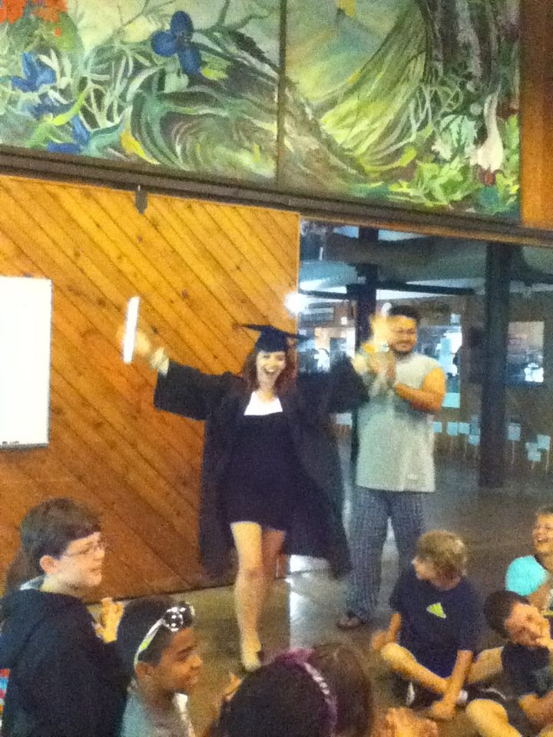

whenever the KODA goes through a situation which perhaps their hearing friends would 'not understand'.

To draw upon a personal example, one summer my father went blind. Having a profoundly Deaf mum this obviously struck my family pretty hard which as a CODA you can probably immediately imagine and empathies with, in a way that no hearing friend immediately got and always had to be walked through. As mentioned, I had no CODA friends growing up so whilst dealing with the implications of 'Deaf Blind' parents (How do they communicate? Will they get divorced? How does our family now operate? Who drives? Who interprets?) All hands seemed to point to me. When I was at breaking point and decided to confer with close friends they sort of squirmed and said 'Oh, Amy ... I ... I ... I don't know what to say' and made me feel bad for mentioning it. Within a day at camp I had told this story, and the responses I got made me at last feel like someone understood the complexity of the situation. My dad is luckily now fine but the condition may hit again at any time and we have run out of remedies. But if this happens again, I now know that I have precious friends who form a close support network in place with whom I can go to who will understand and offer helpful, empathetic support. This is what CODA is all about.

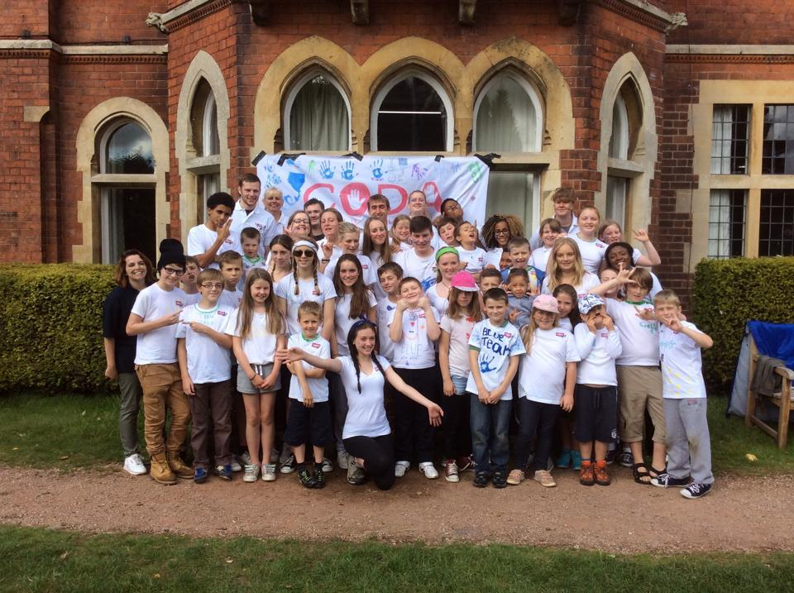

However, do not draw from this that the purpose of KODA Camp is to focus on the negatives of life with Deaf parents. Another one of the huge benefits of KODA activities is to help children to appreciate their unique upbringing: their bilingual and bicultural nature, their innate dual passport into both Deaf and hearing world. The fact that 'independent' and 'mature' children often become good leaders amongst many more benefits such as access to a wonderful, close community, employability skills, becoming bilingual at an early age etc. KODA camp is crucial to help children to appreciate these benefits and to help value the role of sign language not only benefits the KODA but also relationships with the family.

Many parents (my own included) may feel uncomfortable forcing their children to sign. Many believe it is very important to be able to sign as a CODA if your parents sign to support full communication, and therefore closer bonds with parents. Many kids however perhaps aren't that keen to learn or aren’t given the opportunity or resent having to learn. In my experience I have seen children who cannot sign who after two weeks at camp, seeing many of their peers sign, all of a sudden feel that the 'annoying extra' language they may have felt they 'had to' learn was now something 'cool' and a 'secret fun language' and unlocked a world of secret jokes, games, skit roles, sign songs and communication during 'silent lunches' at camp. If KODAs see this language as more than just a language at home they develop a more positive perspective on sign language and may be more enthusiastic to learn this. Camp doesn't explicitly teach children sign language or dictate they have to but through our actions, choice of activities, through respecting and using the language ourselves, valorizing Deaf people and employing strategically placed Deaf staff members we can give Sign Language this additional status to motivate children to learn and respect their language.

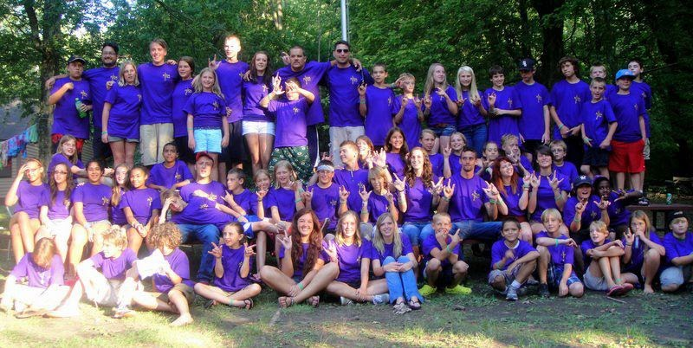

And through this we can encourage many CODAs to give back to, and remain within, the Deaf Community. Many CODAs who perhaps would never have thought about a career in the Deaf sector otherwise all of a sudden meet many CODA adults who are interpreters, Teachers of the Deaf, work in Deaf charities and have their eyes open to a world in which they perhaps had never contemplated working within before. This network of role models also supports young adult CODAs with an early professional network of people they can ask for careers advice from,

whether they be in the Deaf sector or showing them that not all CODAs work within the Deaf sector.

KODA activities develop the idea of a community within a (Deaf) community, it develops the child's sense of identity, self-worth and belief and respect for their parents amongst a whole host of other benefits that I probably haven't even considered yet. Also, most crucially, it’s really fun! So hopefully by this point you have seen why camp is so crucial and why it has become so widespread, so now let’s get down to the nitty gritty of how we make the magic happen!

# 

**CAMP FORMAT**

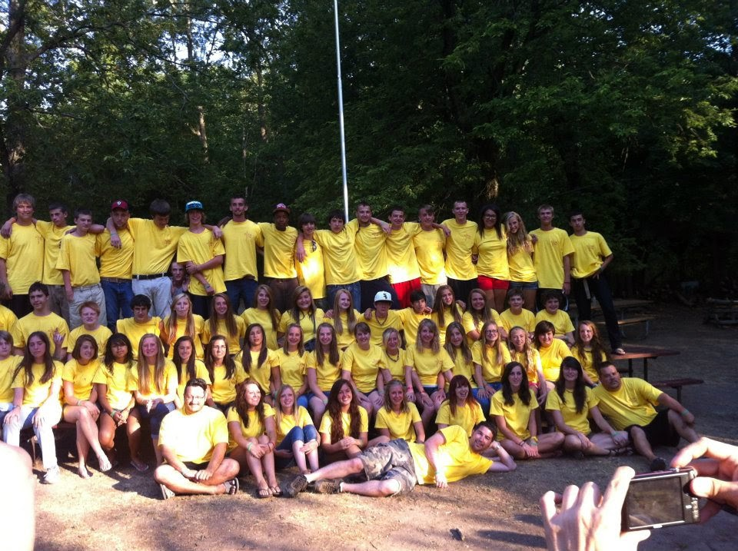

When considering your own camp, consider how many KODAs you know you have in your area, perhaps gauge interest using a survey to see how many you are anticipating and gauge numbers based on this and the amount of staff you can employ. Our trajectory in the UK started small with just 22 children and 5 staff as we knew that was all we could manage at the time. However, as we grew as an organisation, word got out to parents and we gained more volunteers and we are currently selling out a camp of 75 within a week and have around 15-20 volunteers.

Most camps operate with staff (18+, counsellors) and sometimes volunteers (17 years old, “counsellors in training” who are normally ex-campers who transition into formal staff and are given training to support them) as well as possibly cooks, finance directors and general directors. Start small if needed and build from there! Ensure you follow your country’s laws about safeguarding and ensure there is an adequate staff to child ratio. E.g. in the UK it is 1:10 for older children but 1:6 for younger and some children with additional needs may require 1:1 support. You will also probably want some additional staff available for setting up activities, covering breaks etc so you will need to factor this in.

Once you have a gauge of numbers, consider venues and the style of camp you want. Our UK camp has moved from a very KODA-led camp (all activities CODA led using the arts and crafts, PE, team building and Deaf studies model) to a more site-led model based on children’s feedback of what they enjoyed. We attend established sites with exciting activities (water based, climbing based etc.) and choose a programme which is child-led based on their feedback yet also includes elements of the initial model - choosing physical and team building activities and having a first day programme based on icebreaker using PE, Deaf Studies, Arts and Crafts and Team Building. You can use your idea of numbers and vision of your camp model to choose a venue,

ideally somewhere in nature with good quality accommodation and a large space for outdoor activities and indoor space for talent show, disco and other evening activities.

Camp and workshops vary immensely dependent on the culture of the country, the resources available to the organisation and the interest. Based on vague googling I believe we currently have two 2-week long camps (with two sessions of 9-12 and 13-16) in Camp Mark 7 and KODA Camp Midwest, week long camps with a mix of ages (KODA West, KODA Aspen, CODA Norway, CODach) and three to four day long weekend camps in Australia (regional based), New Zealand and the UK. Please contact me if I have missed any out or confused any! Consider your country’s holidays and how common camps are in your country. For instance, in the US it is common for children to go on camps for 2 weeks and even much longer as their vacations are so long so a 2-week camp is fine, however in the UK, 2 weeks would be 1/3rd of our entire holidays! As many parents want to take their kids away themselves or can’t afford campers to be away that long our feedback has said they’d prefer a long weekend model of camp (despite how much we wish it could go on longer!).

Once you have decided on how many children and staff you want and have found a venue you will need to set a budget and cost up camp. These are some of the factors we cost into our camp though you may want to add additional elements for yours:

**CODA Camp Budget**

Venue fees (including accommodation and food for staff and children)

Insurance

Bedding

Staff t-shirts

Children’s t-shirts or wristbands

Training day costs

Travel expenses for staff or staffing costs

Post-camp social for the CODA staff

First aid kits

KODAthalon (obstacle course) equipment

Activity equipment (arts and crafts, PE, team building, awards etc)

Free time games/equipment

Walkie-talkies

Paper

Ink

Financial aid cover

Emergency costs

Phone/tablet - something to be able to contact the parents with, something for them to contact you whilst at camp. This may need video

capabilities.

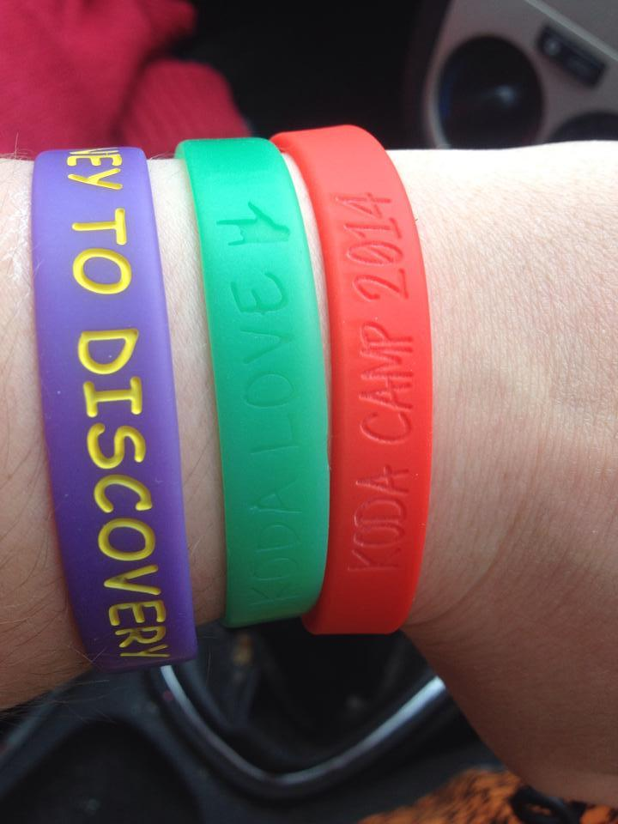

Ensure you have budgeted some contingency money as there will always be things you need to pay for that you may not have considered!

Once you have considered how much camp will cost, make a provisional booking with the venue and cost up how much you will need to charge parents. Many camps budget in enough so that they can offer some financial aid to parents who cannot afford to send their children to camp.

At this point you are ready to start recruiting volunteers and advertising camp. Set a clear deadline for volunteers and ask them to fill in an application form. A copy of ours is on our website www.codaukireland.co.uk if you would like to look at this as well as a copy of our advert and booking form for children. You may want to interview new volunteers to decide who is appropriate and find out about their experience. We use a google forms booking form as it keeps children’s information such as their medical and allergies easily accessible during camp.

**CODA Camp Example Registration Form Questions**

Email address *

Child’s Name *

Date of Birth *

Child's Gender *

Address *

Parent/Guardian Name *

Contact Number *

Doctor Name, address and contact number *

Does your child have any Medical Conditions? *

Does your child have any Emotional, Behavioral or Psychological concerns that we should be aware of? *

Does your child have additional needs and/or 1:1 support in school? *

Is your child currently taking any medication? *

Does your child suffer from any allergies? *

Is there anything your child cannot eat or drink? *

Can your child swim one length (25 meters) without help? *

Does your child need armbands? *

How would you like to pay? * In Full by Bank Transfer/Cheque/GoCardless Direct Debit System

Will you be applying for Financial Support? *

Can you tell us why you are applying for Financial Support?

Is there anything else you would like to let us know?

You may also want to ask parents to give permission for your organisation to take photos, administer medication and agree that all the information is correct and accept risk of injury or loss at camp so that you are not liable.

Ensure you set up some form of method of parents paying you a deposit or paying off costs in chunks to ensure you can pay for venue deposits. Once you have advertised and recruited you are ready to start to consider how to plan and structure your camp. I will go into detail about the

different activities and some examples below but first I will discuss the general routine of the day. Many activities will need a risk assessment to ensure you have thought of potential problems which may arise and have the relevant things around to prevent danger for children.

Please make sure you factor in breaks for staff, obviously the amount of breaks you give to full time paid staff working for 5 weeks straight would probably be longer than breaks for staff who are working over the course of 3-4 days but breaks are crucial as happy, well rested staff means happy campers!

As camp draws closer, ensure you have sent out both camper and staff volunteer welcome packs. Similarly, to the training PowerPoint which we will mention below, the staff welcome packs should include all the essential information staff need to know as well as packing lists, directions to camp, expected arrival times, list of staff coming, contact details etc. Camper welcome packs will include similar information though mainly focusing on packing list, emergency contact information, accommodation, programme, rules and staffing. You can also formally set up the timetable and potentially install it into an app like guidebook or print it out to be displayed at camp. Please contact us if you want an example of our welcome pack.

Also, to be sorted out beforehand is group and room allocations and allocate staff to be responsible for each, which again needs to be printed and shared with staff. Contact parents to check if they have any queries and you could potentially set up a Facebook group so they can arrange ride shares and share photos after (it is also lovely for staff to see the many posts/videos from happy campers!). Ensure you have bought any resources you need for camp and have a packing list ready so you know who is bringing what. Hopefully with all in place, you are ready for camp!  
  
CAMP TRAINING

Camp training will vary dependent on the needs of your staff and should be interesting, engaging and change to reflect the changing needs of staff and children year on year. Dependent on the duration of your camp, training duration and camp set up may vary, for instance during 5 week camps there may be an entire training week which will include planning and resourcing for activities for the time, however shorter camps may only have one day of training and planning and resourcing activities will be completed beforehand. Here is an idea of some various topics which may need to be covered within training:

* Introductions and staff icebreakers
* Safeguarding (ESSENTIAL) – what is your camps safeguarding procedure? What are signs of abuse? Who do you tell? What do you say to children?
* First Aid policy
* Tour of site
* Structure of the camp and programme
* Staff expectations, rules, camper rules
* The groups, ratios and taking breaks
* Specialist information about specific children if needed e.g ADHD training, epilepsy training etc.
* Behaviour management training, spirit points, problem solving and situations practice
* Walkie talkie training
* Kodathalon
* Practice activities
* Group planning/Filler time planning (Split into different ages to plan relevant activities
* Campfire team building time as a staff - campfire, chant training and KODA talk to give staff an experience of what KODA talk is like
* Ask staff before and after if they have anything further, they need to know.

As well as staff training, every evening during camp we hold staff meetings to discuss the positives and negatives of the day, especially making space to report any safeguarding or first aid concerns that other staff may need to be aware of the next day (i.e. ‘So and so hurt their ankle, keep an eye on it and don’t make them run in tomorrow’s activity’ or ‘So and so is being picked on by so and so, please monitor this, group 5’. After camp we have a whole camp review session and send staff and children individual feedback forms so we can develop next year’s training and adapt camp to support campers and staff feedback. If you would like an example of our training PowerPoint feel free to email!

GUIDEBOOK/DAILY TIMETABLE

Guidebook is an app we have started using which has proved very useful. You can install it and encourage staff to download the app and therefore the programme making it easily accessible at any point. It allows you to add any information that you wish to make accessible. We include the following:

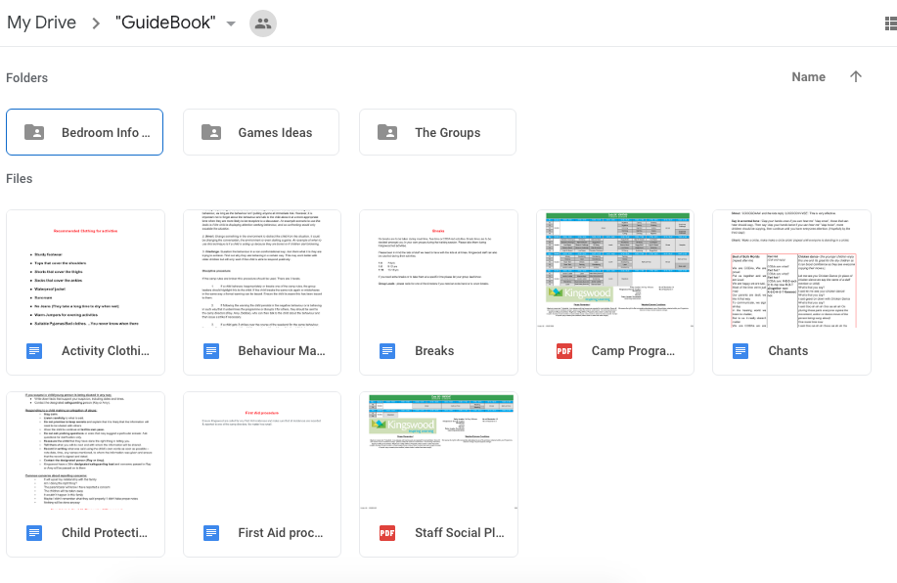

* Packing list
* Programme and timetable
* Groupings
* Children and any medication needs/allergies
* Filler game ideas
* Maps
* KODA talk ideas
* Chants
* Behaviour management strategies
* Photo upload area

You can add anything you think would be useful to staff and staff can add items to their ‘calendar’, ‘group’ or ‘to do’ list. Feedback about guidebook has been generally positive though it is worth considering that as children don’t have the app there is still a need for physical timetables which could be displayed so they know what the timetable is. However recently this has become paid so we have started to do a free “Google drive version”. Creating a guidebook can be a lot of work initially, in subsequent years you can make a copy and just adapt the timetable and campers so it is less work later on! We also started to use lanyards with names on

the front, group names, chants and the timetable so that children could check the timetable easier. Here is an example:

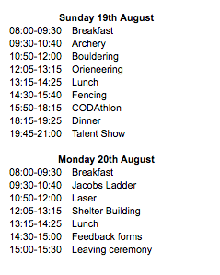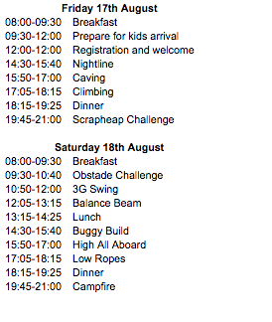

# **CAMP SCHEDULE**

Camp schedules will vary based on the duration but generally the structure will be as follows:

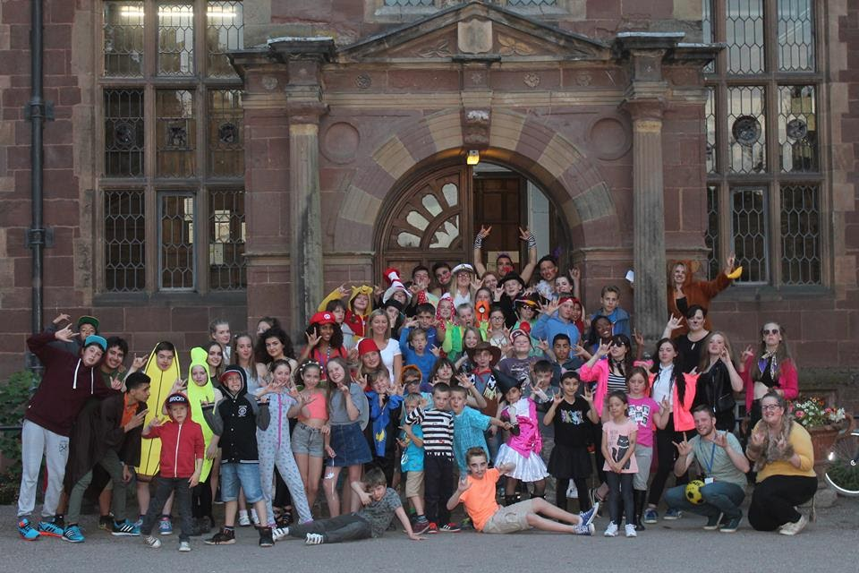

* Wake up campers
* Breakfast
* Morning Exercises/Cleaning (Optional)
* Free time
* Activity 1
* Activity 2
* Activity 3
* Lunch
* Activity 4
* Activity 5
* Activity 6
* Free time/tuck shop
* Evening activity
* Ready for bed
* Lights out
* Camp staff either attend staff review meeting or patrol rooms to check children have gone to bed and there are no issues

This can be modified based on your camp and times are free for you to choose but should be communicated clearly to staff and children. Some days will be different if there are special events (e.g. KODAthalon may take up 2-3 activity slots). Here is our timetable from this year:

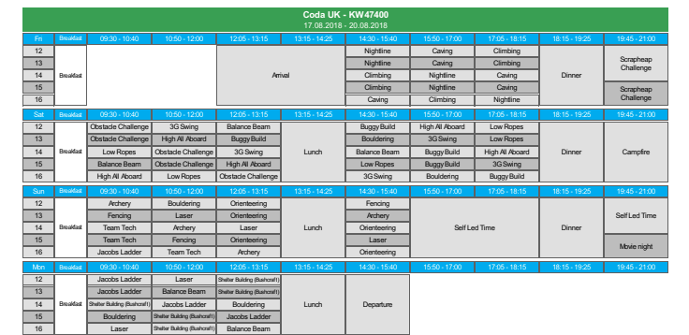

Evening activities will vary but traditionally most camps will have at the minimum: KODA camp fire, talent show and disco. If you have more time you could try events like hobo meals (making a meal and then putting it in foil and cooking on the campfire and eating outside), quiz night, ASL game night (how many signs with that handshape can you think of?), night time hide and seek,  different themed discos/dances (white party, beach party, fancy dress party etc), ‘boys night’ and ‘girls night’, movie night and so on. You could also have a casino night and children can win things like ‘pie-ing a staff member’ - the messier the better!

# 

Be creative and try to switch it up but keep the things campers love! Ensure if there is a themed night or fancy dress required that this is included in the packing list. Another essential thing to ensure you plan in is KODA talk time - this will be discussed in detail below.

Although on the outside it may just seem (and hopefully to the kids it just seems this) like the schedule is based on superficial kids’ games which are fun but really, they are activities that have been carefully selected to complement the skills that KODAs often lack as well as traditional camp activities. At our camp we divided these activities into four sections in order to assist with a balanced programme: this was 'Arts and Crafts', 'Physical Education' as traditional core camp elements and then 'Deaf/KODA Issues' and 'Team Building' to complement KODA specific needs as well as filler games which can be used at any time when there is an activity needed which is where we will begin.

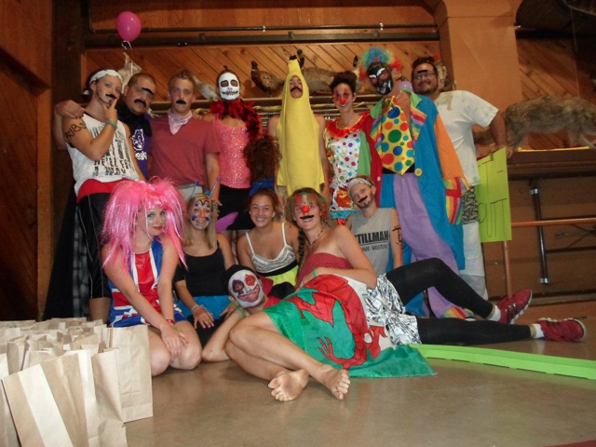

**FREE TIME & FILLER GAMES**

During free time you can suggest games and provide activities or sports such as ‘KODA ball’ (4square) or other games, board games, arts and crafts materials etc. But also, don’t be afraid to give children the time to be free, chill and talk to their new friends, especially with the older children! At times you will find that something has not gone to schedule or children have finished an activity early and you need to whip something out of your sleeve to kill some time so it is great to have some ‘filler games’ to hand.

A great resource for all of the games and activities we will list is <http://www.ultimatecampresource.com>. There is such a plethora of ideas there and enough to keep changing activities every year but to start you off I will name a few of my favourite activities I’ve done over my 8 years of camps.

Werewolf - <http://www.ultimatecampresource.com/site/camp-activity/werewolf.html>

Splat - <http://www.ultimatecampresource.com/site/camp-activity/splat.html> - this has MANY variations like elephant ears and James bond

Indian Chief - <http://www.ultimatecampresource.com/site/camp-activity/circle-game.html>

Port & Starboard - <http://www.ultimatecampresource.com/site/camp-activity/ship-captain.html>

Elves, wizards & giants - <http://www.ultimatecampresource.com/site/camp-activity/giants-wizards-and-elves.html>

Wink murder - <http://www.ultimatecampresource.com/site/camp-activity/wink-murder.html>

Also make sure with filler time that you ask children what games they like; they will often be able to list loads of games and they may be more into those games than any you suggest! Find out the ‘in fashion’ game that year and use that one.

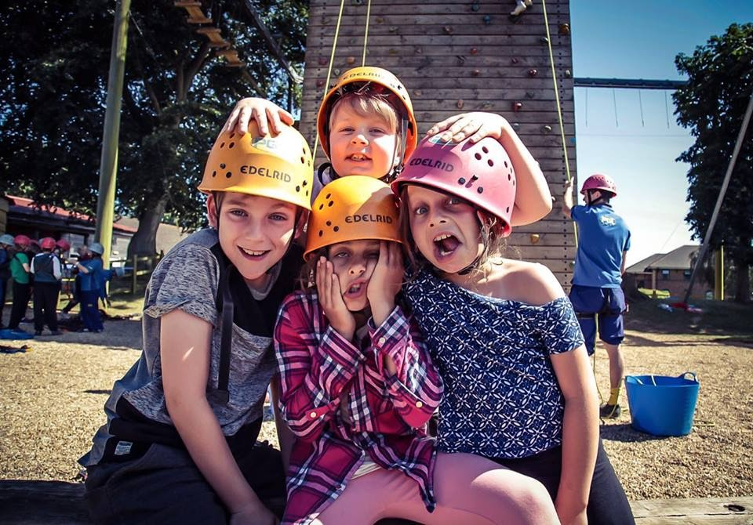

# 

# **ARTS & CRAFTS ACTIVITIES**

It is so important to let children explore their artistic side at camp. Some of the activities we have done in the past include:

* Making a team flag for KODAthalon
* Making a KODA t-shirt design (which could later be made into the camp shirt)
* Tie dye shirts
* Designing ‘compliment books’ for other children to sign with nice things about each other on the last day of camp
* Friendship bracelets to give each other
* Painting photo frames

And many more ideas, check out ultimate camp resource or Pinterest for more ideas!

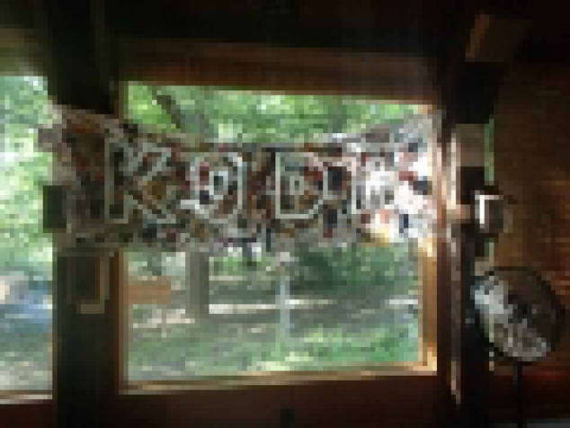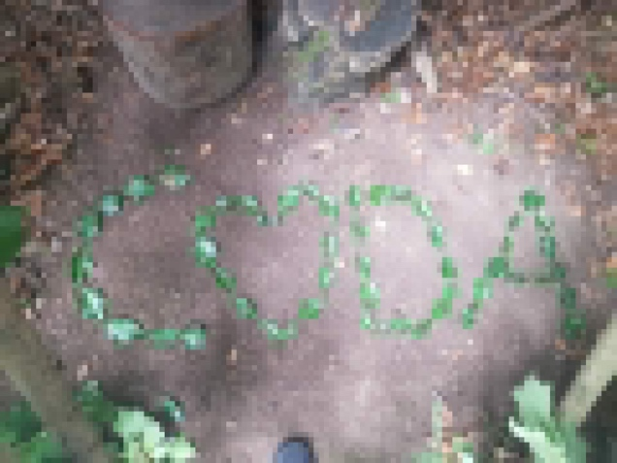

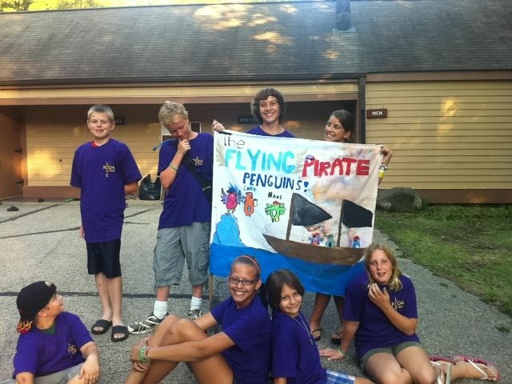

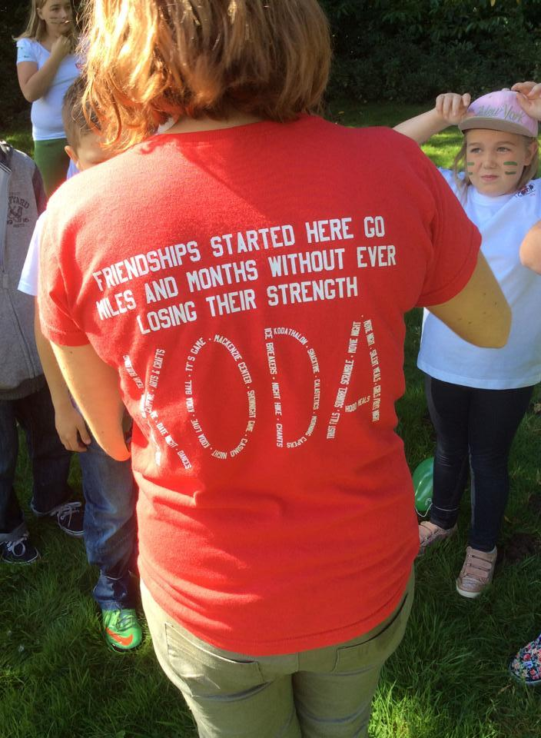

# 

# **TEAM BUILDING GAMES/ICEBREAKERS**

Team Building is a crucial element of camp as people often find that KODAs seem to become very mature at an early age due to a variety of reasons (interpreting responsibilities, viewing oppression of their parents, potentially dealing with economic or social issues, stigmatisation and bullying). As well as maturing early, many grow very independent and struggle to work as a team. For this reason, camps often employ many teams building and trust building games to improve these skills and allow children to rely on their peers more than relying solely on themselves, building the ability to work as a team and not take all things in life on alone. This starts through simple icebreakers and name games and continues throughout camp. This can also include life skills and survival skills like making fires or shelter building.

Ice breakers: <http://www.ultimatecampresource.com/site/camp-activities/ice-breakers.html> and here are some of my favourites:

* Alaskan baseball <http://www.ultimatecampresource.com/site/camp-activity/alaskan-baseball.html>
* Web of names <http://www.ultimatecampresource.com/site/camp-activity/web-of-names.html>
* Move if you <https://www.playworks.org/resource/game-of-the-week-move-if/>
* You me left right:  <http://www.ultimatecampresource.com/site/camp-activity/you-me-left-right.html>

Team building games <http://www.ultimatecampresource.com/site/camp-activities/team-building-activities.html>:

* Trust fall <http://www.ventureteambuilding.co.uk/trust-fall/>
* Trust drop <http://www.ultimatecampresource.com/site/camp-activity/cookie-machine.html>
* Trust circle <http://www.ultimatecampresource.com/site/camp-activity/trust-circle-or-willow-in-the-wind.html>
* Trust walk - <http://www.ultimatecampresource.com/site/camp-activity/trust-walk.html>
* <http://www.ultimatecampresource.com/site/camp-activity/all-together.html> All together
* The Amazing Shrinking Blanket <http://www.ultimatecampresource.com/site/camp-activity/amazing-shrinking-blanket.html>
* Hot Chocolate River <http://www.ultimatecampresource.com/site/camp-activity/hot-chocolate-river.html>
* Human Knot <http://www.ultimatecampresource.com/site/camp-activity/human-knot.html>

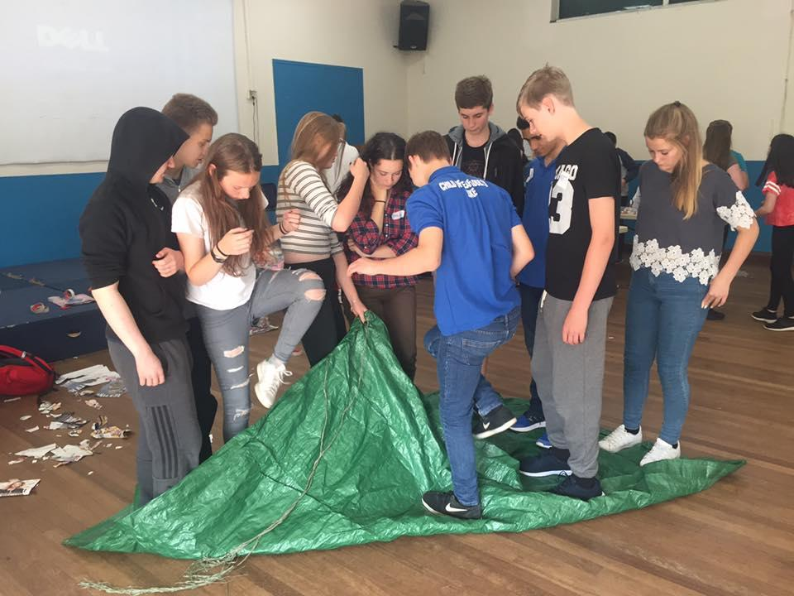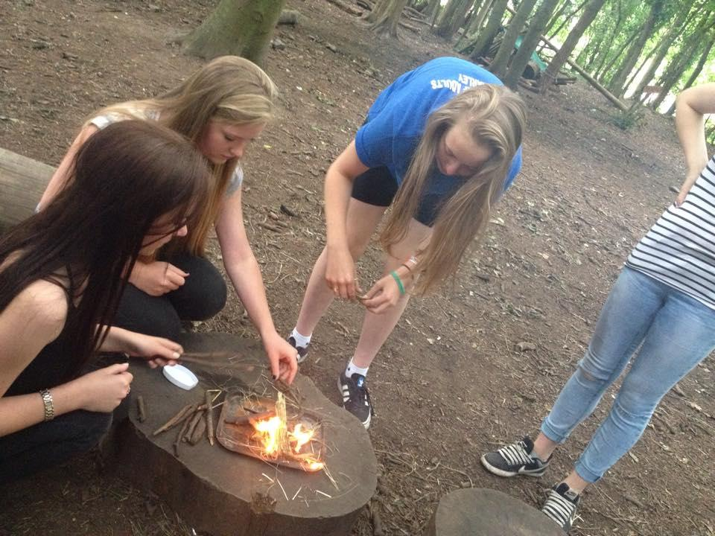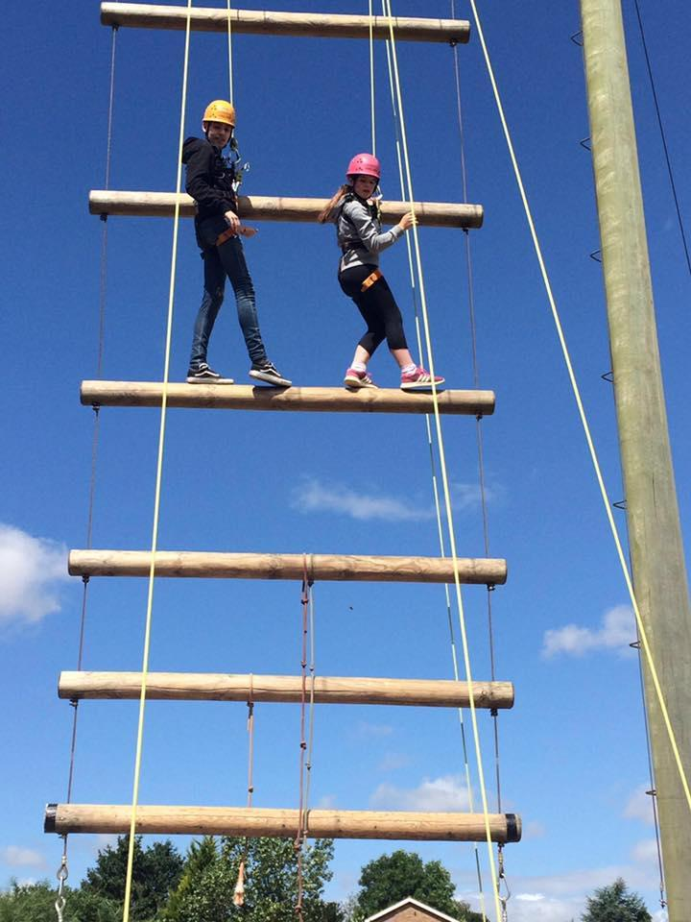

# **DEAF STUDIES/KODA GAMES**

These are the elements that really set KODA Camps apart from traditional camps, it is the ability to explicitly impart awareness of Deaf culture and Deaf identity and how this impact on CODA culture and identity. This can be imparted through games, activities and another big part of this is KODA Talk. Here are a list of Deaf/sign language themed games you could try:

* ABC Hand shape game: if your sign language is one handed you can play the ABC game – start with A and think of a sign or gesture lined to this (e.g. A = fist: could do ‘knocking on the door’) the next person repeats this and then creates their own for B (perhaps opening a door) then C and so on.
* Handshape Game Show – Split camp into teams fairly with a range of ages, give them a handshape (e.g. the 5 handshape) and give them two minutes to write as many signs as they can think of with this handshape in a list. When the time is up, swap papers and mark each other’s and add together the points and move onto another handshape.
* Chinese whispers/”telephone”/minicom! – Similar to the well-known game the aim is to pass a message along the circle to get to the start without changing the message. You can try this in sign language – can they stand in a line, turning around when tapped, receive the sign then pass it along and the message stay the same? Can they do that with fingerspelling? Can they do it with Deaf blind manual sign language? If you want to give them a big challenge/differentiate to the different sign abilities in a group try mixing it up: first child whispers, next child finger spells, next child signs, next child acts it out etc – a truly CODA bilingual game!
* Sign songs – KODAoke! Karaoke but signing the songs!
* Silent lunch – encourage all children to be silent for the entire lunch – they can sign, gesture or write. This gives children a chance to see their peers signing or if they can’t sign to experience how to cope without being able to speak. Provide some sort of penalty for speaking/reward for not speaking (e.g. each child who did it won a small pack of sweets)
* Learn a new sign language and pass on a message – put up ASL, BSL, LSF or some other different signed alphabet, briefly teach children and ask them to try and pass on messages (this is interesting as it allows children to see how different it can be to learn sign language so that they can empathize with their friends who may need to learn it)

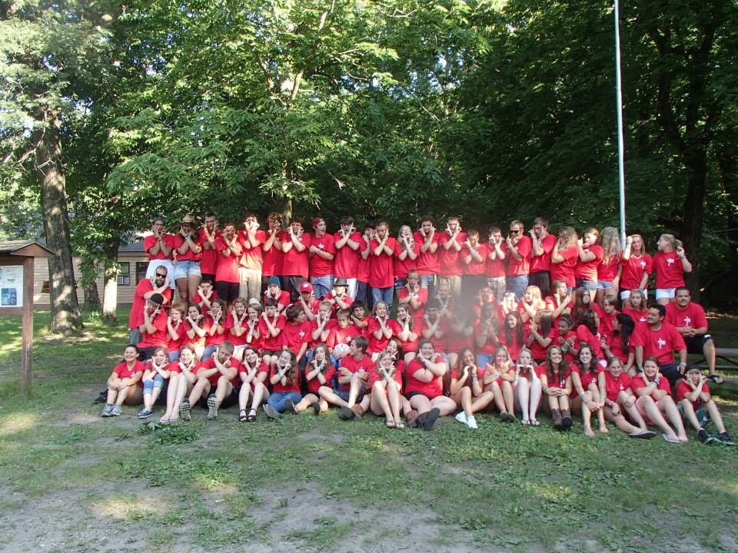

Another big part of this is KODA talk. KODA talk is a really powerful time and a chance for KODAs to chat and talk about their experiences. It is a good chance to let children celebrate their differences and talk about the positive impact of being KODA and also gives them a safe space to discuss any challenges they may experience. It is a chance to see that they have peers with similar experiences and that they are not alone. KODA talk should not be rigid and overly structured, adults are merely there to facilitate children’s discussions. In fact, one thing adults need to monitor is not taking over a conversation too much – we have an adult KODA talk during the training day so that we can discuss our experiences – we need to give children their space to discuss their experiences!

We advise to start off with a question or story and pass around a talking stick to discuss what was raised – normally you’ll find all the children have something to say and conversation naturally flows from one topic into another without needing much adult input. If one conversation dies out then the adult can introduce a new question or story to start conversation again. Generally, KODA talks are pretty flexible however if more structure is needed or you want some ideas here is a list of possible questions you could discuss. We have trialed using these as printed out questions so children can independently choose their question and ask it to the group which worked well:

* What is your name sign? (If not, what would it be?)
* What does being a KODA mean to you?
* Who is Deaf in your family? And how do you communicate?
* Have you ever gone to CODA/Deaf events?
* Did you know what a KODA was before you came here?
* Do you have a lot of Deaf/KODA friends at home/around where you live?
* How did your parents become Deaf?
* How do you explain having Deaf parents to hearing people?
* Do you have Deaf grandparents? If not, how did your grandparents communicate with your parents?
* How do your parents say your name verbally?
* How do your parents communicate with their family (siblings)?
* What's something that has stuck in your mind in relation to Deaf individuals/ your parents?
* Funniest experience being a KODA
* What is your favorite part about being a KODA/most fun part/perks?
* What are some silly questions you have been asked?
* What are some people's reactions when you tell them you have Deaf parents?
* How many years have you been coming to camp?
* Did you choose to come to camp or were you forced to?
* When did you realize you were a KODA?
* What's a time when you felt (embarrassed/proud/frustrated/impatient/happy/glad) about being a KODA or having Deaf parents?
* How would your life be different if you didn't have Deaf parents?
* How do you balance being a KODA in both the Deaf and Hearing world?
* What are the differences between your KODA friends and friends at home?
* Is it easier to make friends here? If so why?
* If you could turn your parents hearing for one day, would you and why?
* What's the funniest experience you've had?
* What’s your favorite/worst thing about having Deaf parents?
* What misconceptions do hearing people have of Deaf people? How do you feel when you have to explain?
* Do you think being bilingual makes you bicultural?
* How do you think having Deaf parents has shaped your personality?
* What sets KODA Camp apart from life at home? or other camps?
* What have been your experiences of bringing hearing friends home to Deaf parents?
* What do you take away from KODA camp?
* What did you learn about yourself as a KODA? What did you learn about KODAs?
* How would you explain camp to a stranger? /someone who has no connection to Deaf community?
* What will you tell your parents about camp?
* Has camp changed your perspective on being a KODA? What were you most surprised about when coming to camp?
* How did you feel when you found out you were coming and how does that compare to now?
* What are some hard truths about being a KODA?
* How is your personality here vs. home?
* How will you maintain your KODA friendships made here?

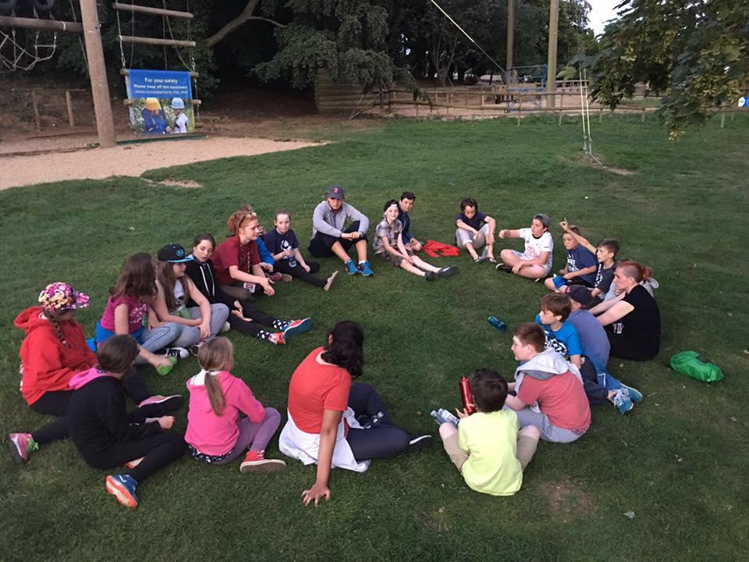

# PHYSICAL EDUCATION GAMES

PE is so important and such a fun part of camp! Daily physical exercise is crucial for all children so consider how you can implement it into camp. Could children go for a morning run or yoga classes? Could they participate in a KODAthalon? How about using the centers facilities for climbing, watersports or even if they don’t have much there can be ball and tag games. If your site doesn’t have activities could you take children on a trip to a pool or waterpark? Can you add in risk, height, adventure and challenge by doing activities like zip wires or climbing?

Some of my favourite activities to run with children have been:

* Ball games (volleyball, football, basketball, dodgeball, KODA ball etc, ask the children what they like!)
* Tag games (there are so many variations! Start off with normal tag then branch into spider tag, stuck in the mud, toilet tag, lizard tag, everyone’s it or many others!)
* 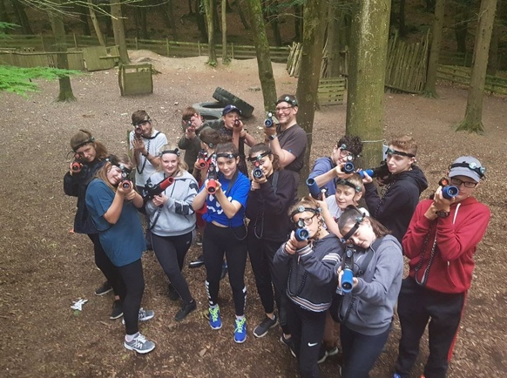Capture the flag
* Noodle hockey

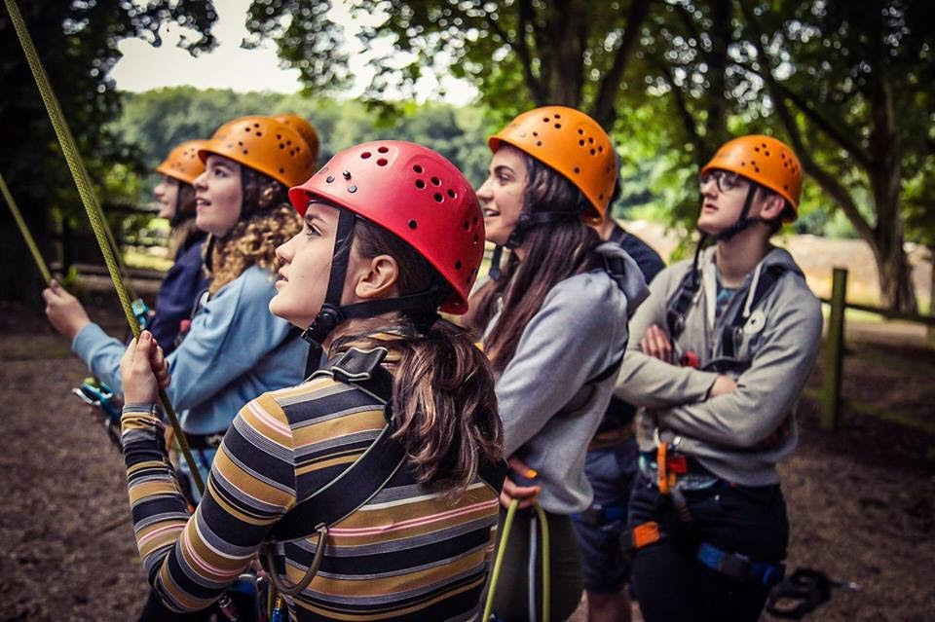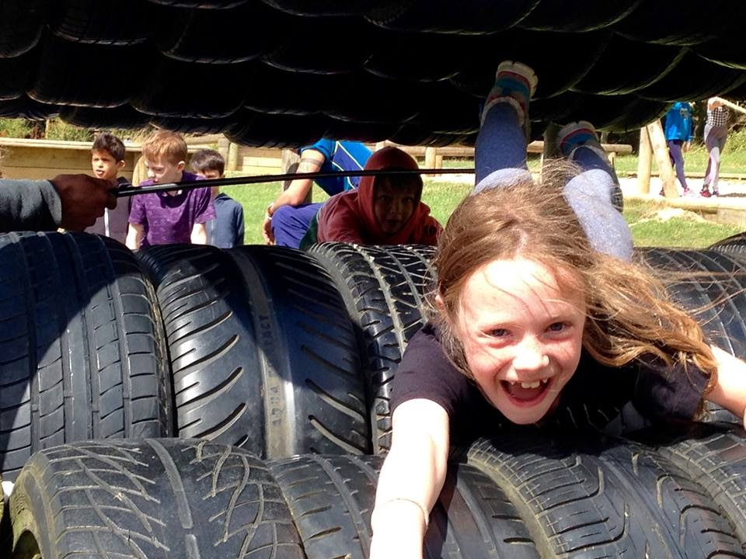

# **DEAF INVOLVEMENT**

Deaf staff/volunteers/leaders are involved in a variety of manners. There is definitely a benefit to the involvement of Deaf people and seeking feedback from parents as KODAs will only come through involvement and respect from Deaf parents. KODA Mid-West is run by the Camp Director who is a Deaf mother herself. She is wonderful in involving, engaging and keeping parents up to date prior to, during and after camp but also strives to keep away during camp to leave the KODAs to be KODAs. She ensures she is not present for sessions such as KODA talk or camp fire to ensure KODAs feel like they have a “safe space” to discuss their experiences without feeling influenced by her presence.

The camp also employs Deaf kitchen staff which act as Deaf role models who are not necessarily involved in the running of activities, meaning kids are free to use whichever language they are comfortable in without feeling like 'Ugh, I have to sign again like at home' due to Deaf presence (often resulting in kids signing anyway but through their own choice!). These staff are often chosen due to their personalities as fun and inspiring Deaf people who are considered by most of the kids as 'cool'. As someone who grew up going to a Deaf club with almost exclusively older Deaf people, I can definitely see how having Deaf role models who are 'on the kids’ level' can change perspectives about Deaf people and their own personal involvement in the Deaf community.

This is my personal involvement based on one camp however each camp and the situation of the country itself varies. For instance, in New Zealand as holidays are in 'summer' (Christmas) most camps will revolve around the family so Deaf parents will be present. Some camps can be run in parallel with Deaf camp programmes, mixing with the other camp but separating for certain KODA only activities.

**KODATHALON**

Kodathalon is a large part of the team building/PE elements of camp and is often considered a highlight of camp. KODAthalon is normally the penultimate day of camp. Children are mixed up into new teams and create team names, team chants and potentially team flags. They wear matching t-shirts and use a colour to identify their team. They work together as an age-balanced team against other teams in a range of challenges (the messier the better!) and finally in a big obstacle course which gets very wet! Throughout the event they can collect spirit points for being more positive, working together and cheering on their peers. Finally, the winning team is announced and given a prize – often the right to use the remainder of the water guns, balloons and buckets on all the other children and staff! Expect mental mayhem and getting super soaked! Here are some ideas of activities you can run:  
  
Fashion show – dress up their staff member in the most insane way using whatever limited resources are available

Mexican standoff – children stand back to back each armed with a water gun, on the staffs mark they walk three paces and then squirt each other – staff to decide who is more wet.

Dizzy bat obstacle course: The start and bucket lines should be about 20 feet apart. The player must then run to the bucket, fill up their cups, spin around with their head on the bat 5 or 10 times then pick up the tray and bring it back to their team at the start line and empty into a bucket and gives the next person in line a high five, and then they go and so on until the whole team is done. Meanwhile staff soak the dizzy kids with as many water balloons and guns to knock down their trays. Winner has most water in the bucket at the end!

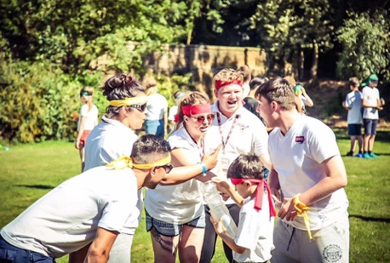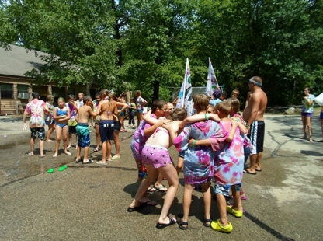

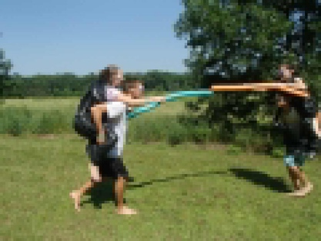

# CHANTS

Chants are another crucial element of camp. Being able to walk around camp or off site and proudly proclaiming that we are CODAs and proud can encourage children to feel this way and part of our community. They’re also really fun! You can make up your own and use generic camp chants <http://www.ultimatecampresource.com/site/camp-activities/camp-songs.html> or use some of our KODA related chants listed below:

KODAs are what?   
*Red hot!*KODAs are what?   
*Red hot!*KODAs are R-E-D sock it to me now H-O-T altogether now R-E-D-H-O-T Reeeeed hot

K-O-D-A   
*What's that? What's that?*  
K-O-D-A   
*What's that? What's that?*  
We're kids of deaf adults!

We're kids of deaf adults!

We're kids of deaf adults!

WE'RE KIDS OF DEAF ADULTS

WOOOOOO

(In army chant style)

We are KODAs, We are proud  
Put us together and we are Loud   
We are happy, we are sad,   
Most of the time we're just mad   
Our parents are deaf, we like it that way   
To communicate, we sign all day   
In the hearing world we listen to chatter,   
But to us it really doesn't matter   
We are KODAs we are proud,   
Put us together and **WE ARE LOUD**!

**Chicken dance-** the children love this one and it’s great for the shy children as it can boost confidence as they see everyone copying their moves. Not so great for staff voices as you have to go through this for every staff and child so that's 75 times and you need to know their surnames! May be better if you only do it in smaller groups :)

Let me see your ___[name e.g. Amy Claridge]____

*What's that you say?*  
I said let me see your Amy Claridge!  
What's that you say?   
I said geeet on down with Amy Claridge!  
What's that you say?   
I said Ooh ah ah ah Ooh ah ah ah Ooh *(during these parts everyone copies the movement, action or dance move of the person being sung about)*  
One more time now   
I said Ooh ah ah ah Ooh ah ah ah Ooh

**Attention getting techniques:**

**Shout:**'COOODDAAA' and the kids reply 'LOOOOOVVVEE'

**Shout:** When I say KODA, you say LOVE: KODA: *LOVE*, KODA: *LOVE*

**Chant:** 'Make a circle, make make a circle circle' (repeat until everyone is standing in a circle)  
  
Same chant rhythm for: 'Take a photo, take take a photo photo' (Until everyone is ready)

**Say in a normal tone:** 'Clap your hands once if you can hear me' *clap once*, those that can hear should copy. Then say 'clap your hands twice if you can hear me' *clap twice*, more children should be copying, then continue until you have everyone’s attention. (Hopefully by the third clap!)

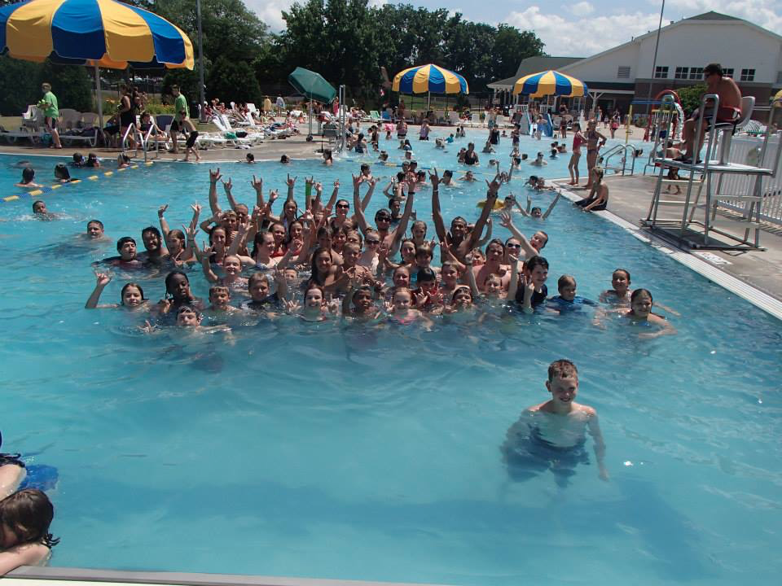

# BEHAVIOUR MANAGEMENT

At camp the main aim is to enable all children to have fun, therefore the focus is on positive behaviour management, encouraging children to be respectful through encouraging good behaviour. We do this through spirit points. Spirit points can be given to any camper, by any member of staff. The idea of this is encourage and reward good behaviour. Staff should ensure they log the spirit points and at the end of each day, through the staff meeting/debrief, log these points on the main scoreboard. Giving points out is at your own discretion, so don’t be afraid to give out as many as you wish! At the end of camp, the child with the most points will be crowned Camp King or Queen. When challenging behaviour occurs we use the following strategies:

**Delay, Divert or Challenge?**

*1.* ***Delay*** responding to the behaviour**.** Acknowledge the person without confronting the behaviour, as long as the behaviour isn't putting anyone at immediate risk. However, it is important not to forget about the behaviour and talk to the child about it at a more appropriate time when they are more likely to be receptive to a discussion. *An example scenario to use this tactic is if the child is displaying attention seeking behaviour, and so confronting would only escalate the situation.*

*2.* ***Divert.***Change something in the environment to distract the child from the situation. It could be changing the conversation, the environment or even starting a game*. An example of when to use this technique is if a child is acting up because they are bored or if children start bickering.*

*3.* ***Challenge*.** Question the behaviour in a non-confrontational way. Ask them what it is they are trying to achieve. Find out why they are behaving in a certain way. This may work better with older children but will only work if the child is able to respond positively.

**Discipline procedure:**

Camp should have clear rules to ensure all children are safe and happy at camp. If the camp rules are broken this procedure should be used. There are 3 levels.

1. If a child behaves inappropriately or breaks one of the camp rules, the group leaders should highlight this to the child. If the child breaks the same rule again or misbehaves in the same way a formal warning can be issued. Ensure the child is aware this has been issued to them.
2. If following the warning the child persists in the negative behaviour or is behaving in such way that it undermines the programme or disrupts it for others, they should be sent to the camp directors, who can then talk to the child about the behaviour and then issue a strike if necessary.
3. If a child gets 3 strikes over the course of the weekend for the same behaviour, the camp director may contact the child's parents and it could result in the child being sent home.

*Only the camp or assistant camp directors can issue strikes and a behaviour form will be completed.*

As members of staff at camp, you are role models for all campers, so please ensure you are modelling good attitudes and behaviour throughout camp. Following the principles below should ensure you are able to do this!

**Positive Actions –** Be aware of your influential position, practice what you preach.

**Think out loud –** Think out loud when decision making, demonstrating how to problem solve.

**Apologise and admit mistakes -** If you make a poor decision or mistake, admit this openly, and discuss how you will correct it. This will encourage campers to take responsibility for their own actions.

**Follow through -** Doing what we say we will, following our plans, and delivering what we said we would, shows our campers to be committed and to have self-discipline.

**Show respect -** Be respectful of both campers and other staff members, enforcing the message to treat others as you wish to be treated.

**Be confident -** Campers will follow your lead, so ensure you are demonstrating self confidence in your decisions and initiative taking.

# 

# **WORKSHOPS**

If your organisation is not yet sure if it has sufficient children to set up a camp or wants to follow on from successes of camp and to carry on the meet ups during the remainder of the year you may want to set up workshops. These can be as often as is feasible for the volunteers though normally it is once a month. Workshops can follow a theme (e.g. drama workshops, art workshops) or vary based on feedback from children. It is good to keep content varied and child-led. If you find it hard to secure funding to hire out a room and purchase resources you could also consider taking children on trips and asking parents if they can fund the cost. For instance, we have run trips to theme parks and asked parents to cover £15 for the costs.

It is worth reaching out to Deaf clubs to see if they have a room you can hire. Working with and building a relationship with Deaf parents is crucial as then they will be aware of CODA events and bring their children. If you cover a wider area try to set up different workshops in different areas to enable more children to access these events. Once the workshop is established you can empower children to be involved in advertising the workshops (e.g. an open event advertising CODA to the community, creating videos and posters) and fundraising to enable workshops to continue (e.g. bag packing in supermarkets, sponsored walks, sponsored silences, making crafts or cakes to sell etc). Here are some ideas of workshops that we have run:

Drama workshop - filming skits

PE/games workshop

Climbing

Theme Park

Bowling

Water park

Ice Cream Making

Art Focus

CODAthalon event at CODA Conference with Conference attendees and children (see below)

Film showing - CODA movie ‘La Famille Beliere’

Themed events - Halloween/Christmas party (see below)

Deaf History/Deaf Studies focus

Fundraising - bag packing

Sponsored Walk

Colour Run

Again, you will need to ensure you have budgeted accordingly and then either charge parents enough to cover these costs or you can apply for funding and budget with this funding in mind. We have obtained funding through national organisations, local organisations where workshops have been set up, through CODAs 4 KODAs and through our own CODA fundraising. Things to ensure you have budgeted are:

* Volunteer travel
* Venue hire costs
* Materials cost for activities/tickets for any activities
* Food (if provided)
* Organisation insurance
* First aid costs
* Paper/printing for sign in lists etc

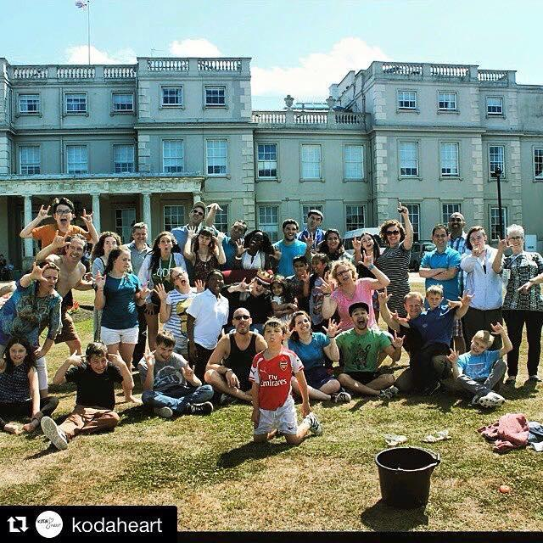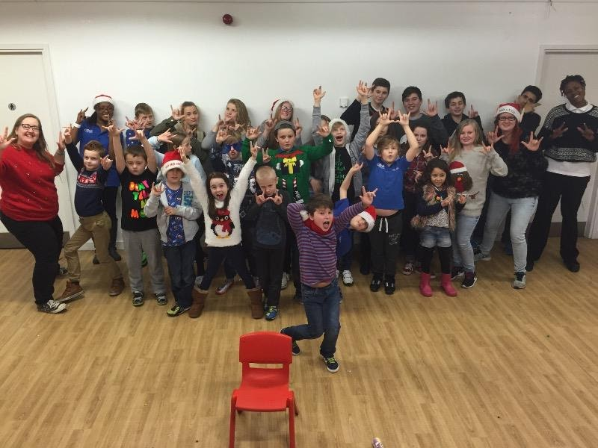

# **KODA to CODA**

# Once children turn 18, they become ‘CODAs’, it is essential that we support these children into the adult CODA community. It can be overwhelming for children to feel like they are losing their community that they have made through camp and although they can return as staff some may not be able to do so. This is why encouraging children to gain their friends contact details can help so they can stay in contact. Also running events throughout the year for both children and adults can also help. It is also worth making sure children know that CODA International exists and that hundreds of CODAs from around the world gather together once a year. Check out their website here for more information and details on the next annual CODA Conference: [www.coda-international.org](https://l.facebook.com/l.php?u=http%3A%2F%2Fwww.coda-international.org%2F%3Ffbclid%3DIwAR146xid6th73Xa1zA839GggQKpK6CsyxQrLRVENKgyBhA6N19QpeFZDjzE&h=AT1Ga925C637s0TN33wcKKOVvlppgtQ6jVizU8NBTEy9aM1NHmrrsFDi1RQyV0b87_W-9OHYXzbm4Er5RT8k9rXfarVbagWvlzWObYLkpQW3RMN6jQylsW9EDN8ljf8RFjVO8hI)

# **CONCLUSION**

I hope this guide has been useful to you in some way. If you are an organisation looking to set up a KODA Camp please do contact CODA International and join the CODAs-4-KODAs group on facebook. We are a very international community and I’m proud of our spirit of community, knowledge sharing and support we have for each other. We are all here to ensure KODAs have the best start in life and are aware of their identity and have a network of peers who also understand that identity. There are many CODAs out there who have a lot of experience in KODA camps so do post to see if other CODAs may be able to volunteer and join as staff! Please if you have any further questions or any suggestions for any additions or if you would like to visit or volunteer for our camp in the UK please do contact me at [amy@codaukireland.co.uk](mailto:amy@codaukireland.co.uk).

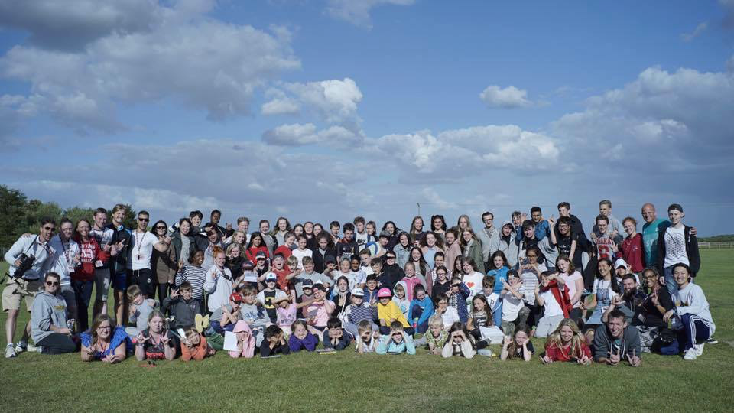Best of luck and as always – CODA LOVE!